Push the image to the IBM Cloud Registry

- From your account dashboard, go to IBM Cloud Kubernetes Service.

- From the left navigation menu, select Private Repositories.
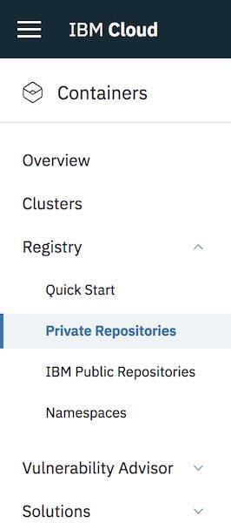

- Install the Container Registry plug-in.
- ibmcloud plugin install container-registry -r "IBM Cloud"

- Log in to your IBM Cloud account.

- ibmcloud login -a <cloud_foundary_end_point_for_the_region>

7. Name and create your namespace. Use this namespace for the rest of the Quick Start.

- ibmcloud cr namespace-add <namespace>

- Log your local Docker daemon into the IBM Cloud Container Registry.
- ibmcloud cr login

- Choose a repository and tag by which you can identify the image.
- docker tag <image_name> <region_url>/<namespace>/<image_name>:<tag>

- Push the image.
- docker push <region_url>/<namespace>/<image_name>:<tag>


- Verify that your image is in your private registry.
- ibmcloud cr image-list
